“Melango”

an all-in-one learning web application

1. Introduction

1.1 Purpose
This Software Requirements Specification (SRS) document outlines the requirements for developing "Melango", an all-in-one online learning web application using the MERN stack (MongoDB, Express.js, React.js, and Node.js). The primary goal of this application is to provide a secure, efficient, and user-friendly learning platform that enables students and learners to discover language and skill-based courses, access practical exercises and quizzes, schedule assessments, receive feedback on their progress, and make secure online payments.

1.2 Scope
The scope of this project includes the design, development, testing, and deployment of the Melango online learning web application, catering to:
- Learners, who can register, browse courses, purchase premium courses, access both free and paid learning materials, take quizzes and assessments, track their learning progress, and receive feedback.
- Teachers, who can create and manage courses, upload learning materials, create quizzes and assignments, evaluate student submissions, and monitor learners' progress.
- Administrators, who oversee system operations, manage users and courses, monitor platform activities, generate reports, and maintain the overall functionality and security of the application.
This SRS covers the functional and non-functional requirements of the project, including its constraints, assumptions, high-level system design, and the development plan following the Agile methodology.

1.3 Definitions, Acronyms, and Abbreviations
- MERN: MongoDB, Express.js, React.js, and Node.js.
- MVC: Model-View-Controller, a software architecture that separates the application into Model, View, and Controller components.
- LMS: Learning Management System.
- API: Application Programming Interface.
- REST: Representational State Transfer, an architectural style used for communication between the frontend and backend.
- JWT: JSON Web Token, used for secure user authentication and authorization.
- RBAC: Role-Based Access Control.

1.4 References
The following official documentation and resources will be used during the design and development of the project:
- MongoDB Documentation
- Express.js Documentation
- React Documentation
- Node.js Documentation
- Mongoose Documentation
- Bootstrap Documentation
- GitHub Documentation

1.5 Overview
Section 2 provides an overall description of the Melango online learning platform, including its user classes, product features, operating environment, constraints, and assumptions. Section 3 describes the functional and non-functional requirements, as well as the external interface requirements. Section 4 presents the technology stack and high-level system architecture. Section 5 outlines the Agile development plan, including the sprint-wise breakdown and deliverables. Finally, Section 6 defines the acceptance criteria, and Section 7 concludes the document.

2. Overall Description

2.1 Product Perspective
Melango is a standalone online learning web application built using the MERN stack (MongoDB, Express.js, React.js, and Node.js). The platform provides learners with access to language and skill-based courses, quizzes, assignments, assessments, and progress tracking. It also enables teachers to create and manage courses and allows administrators to manage users, courses, and platform activities.
The application integrates with external services where necessary, such as payment gateways for course purchases and email services for notifications and account verification. The system is designed to provide a secure, reliable, and user-friendly learning experience while following the MVC architecture.

2.2 Product Features

1. Dashboard: Displays total courses, quizzes, assignments, announcements, recent activities, and upcoming deadlines for each user.

2. Announcement Board: Allows teachers and administrators to post announcements while students can view the latest updates.

3. Course Management:Teachers and administrators can create, edit, delete, and organize courses.

4. Learning Materials Repository: Provides video lectures, PDF notes, slides, and downloadable learning resources for enrolled students.

5. Course Enrollment:Students can enroll in courses using an enrollment code or invitation and access course content.

6. Quiz & Assessment:Students can attempt quizzes and assessments with automatic scoring and instant result generation.

7. Assignment Management:Teachers can create, edit, schedule, and evaluate assignments, while students can submit and resubmit their work before the deadline.

8. Discussion & Messaging: Supports discussion forums and direct messaging between teachers and students for effective communication.

9. Notifications & Calendar:Sends email and in-app notifications for announcements, assignments, quizzes, and displays deadlines through a calendar.

10. Progress Tracking & Certification: Tracks learner progress, maintains submission history, generates certificates after course completion, and allows students to rate and review completed courses.

2.3 User Classes and Characteristics
1. Students/Learners: Individuals who enroll in courses, access learning materials, complete quizzes and assignments, participate in discussions, monitor their progress, and receive certificates. They require a simple, responsive, and user-friendly learning environment.
2. Teachers: Instructors who create and manage courses, upload learning materials, create quizzes and assignments, post announcements, evaluate submissions, provide feedback, and monitor students' learning progress.
3. Administrators: System administrators responsible for managing users, courses, announcements, categories, platform settings, reports, and overall system security. They have complete access to all administrative functions.

2.4 Operating Environment

Web Application: Accessible through modern web browsers such as Google Chrome, Mozilla Firefox, Microsoft Edge, and Safari.

Mobile Compatibility: Responsive interface supporting smartphones, tablets, laptops, and desktop computers.

Server-Side: Node.js and Express.js running on a local server or cloud-based environment.

Database: MongoDB database for storing users, courses, quizzes, assignments, submissions, announcements, certificates, and other application data.

Hosting: The application can be deployed on cloud platforms such as AWS, Microsoft Azure, Google Cloud Platform, or equivalent hosting services.

2.5 Constraints
- MVC Architecture:The application must follow the Model-View-Controller (MVC) architecture.
- Security: User information, passwords, and payment details must be protected using secure authentication and HTTPS communication.
- Performance: The application should provide a fast and responsive learning experience under normal usage conditions.
- Scalability:The system should support future expansion with additional users, courses, quizzes, and learning resources.
- Time & Resources: The project will be completed within the allocated academic timeline by a team of four members using GitHub for version control.

2.6 Assumptions and Dependencies

Users have a stable internet connection to access online learning materials, quizzes, and assignments.
- Third-party services such as payment gateways and Gmail email services are available and function reliably.
- Users access the application through a modern web browser supporting JavaScript and responsive web technologies.
- Team members use GitHub for collaboration and version control throughout the development process.

3. System Requirements

3.1 Functional Requirements

3.1.1 Dashboard & Course Management
- FR-1: The system shall display a dashboard showing the total number of courses, assignments, announcements, and upcoming deadlines.
- FR-2: The system shall provide an announcement board where teachers can post announcements and students can view them.
- FR-3: The system shall allow teachers and administrators to create, edit, and delete courses.
- FR-4: The system shall provide a learning materials repository where teachers can upload and students can download PDFs, slides, and other course materials.
- FR-5: The system shall allow students to enroll in courses using an enrollment code or invitation.

3.1.2 Assignment Management
- FR-6: The system shall allow teachers to create, edit, delete, and schedule assignments.
- FR-7: The system shall allow students to submit assignments using files, text, or links.

3.1.3 Communication & Notifications
- FR-8: The system shall notify users about new announcements, assignments, and upcoming deadlines.
- FR-9: The system shall provide a discussion forum where students and teachers can create posts and reply to discussions.
- FR-10: The system shall display assignment due dates and course events on a calendar.

3.1.4 Student Monitoring & Interaction
- FR-11: The system shall allow teachers to record attendance, and students shall be able to view their attendance records.
- FR-12: The system shall allow teachers to provide feedback on assignments, and students shall be able to view the feedback.
- FR-13: The system shall support direct messaging between students and teachers.
- FR-14: The system shall allow users to search for courses by name, instructor, or category.
- FR-15: The system shall allow students to rate and review completed courses.

3.1.5 Progress & Completion
- FR-16: The system shall generate certificates for students upon successful course completion.
- FR-17: The system shall allow students to resubmit assignments before the submission deadline.
- FR-18: The system shall display a recent activity feed showing new uploads, submissions, and announcements.
- FR-19: The system shall track and display the percentage of completed course materials and assignments.
- FR-20: The system shall maintain a history of submitted assignments and display their submission status.

3.2 Non-Functional Requirements

3.2.1 Performance Requirements
- NFR-1: The system shall support multiple concurrent users accessing courses, assignments, and learning materials without significant performance degradation.
- NFR-2: The average page load time shall not exceed 3 seconds under normal network conditions.

3.2.2 Security Requirements
- NFR-3: All communication between the client and server shall occur over HTTPS (SSL/TLS).
- NFR-4: Sensitive user information, including passwords and payment details, shall be securely encrypted or hashed before storage.
- NFR-5: The system shall implement authentication and role-based access control (RBAC) to ensure that users can only access features permitted for their roles.

3.2.3 Reliability & Availability
- NFR-6: The system shall maintain high availability during normal operation, excluding scheduled maintenance.
- NFR-7: The system shall perform regular database backups to minimize data loss in the event of system failure.

3.2.4 Maintainability
- NFR-8: The application shall follow the MVC architecture with a clear separation of Models, Views, and Controllers to improve maintainability.
- NFR-9: The codebase shall follow consistent naming conventions, proper documentation, and reusable coding practices to simplify future maintenance.

3.2.5 Scalability
- NFR-10: The system architecture shall support the addition of new users, courses, and learning resources with minimal changes to the existing application.

3.3 External Interface Requirements

3.3.1 User Interfaces
- UI-1: The system shall provide a responsive web interface developed using React.js that adapts to desktop, tablet, and mobile devices.
- UI-2: The system shall provide separate dashboards for learners, teachers, and administrators with intuitive navigation.

3.3.2 Hardware Interfaces
- HI-1: No specific hardware is required. The application shall run on standard computers, laptops, tablets, and smartphones with internet access.

3.3.3 Software Interfaces
- SI-1: The system shall integrate with a payment gateway (e.g., Stripe, SSLCommerz, or equivalent) for premium course purchases.
- SI-2: The system shall integrate with an email service to send account notifications, announcements, and important updates.
- SI-3: The system shall use MongoDB as the database management system for storing user, course, and assignment data.

3.3.4 Communication Interfaces
- CI-1: RESTful APIs shall be used for communication between the React.js frontend and the Node.js/Express.js backend.
- CI-2: All client-server communication shall use the HTTP/HTTPS protocol, with HTTPS enabled for secure data transmission.

4. Technology Stack & Architectural Overview
4.1 MERN Stack Components
- MongoDB: Document-oriented NoSQL database used to store user accounts, courses, quizzes, assignments, submissions, announcements, attendance, certificates, and progress records.
- Express.js:Node.js framework used to build RESTful APIs, process client requests, implement business logic, and communicate with MongoDB.
- React.js: Frontend JavaScript library used to create responsive dashboards, course pages, quizzes, assignment pages, announcements, and other user interfaces.
- Node.js:JavaScript runtime environment used to execute the backend application and manage server-side operations.
- Bootstrap:CSS framework used to build responsive, mobile-friendly, and visually consistent user interfaces quickly.
4.2 High-Level Architecture
- Presentation Layer (React.js):Handles user interaction, displays dashboards, courses, quizzes, assignments, announcements, notifications, calendars, certificates, and communicates with the backend through RESTful APIs.
- Business Logic Layer (Express.js/Node.js): Processes user requests, manages authentication, course enrollment, quizzes, assignments, messaging, notifications, progress tracking, certificate generation, and business rules.
- Data Layer (MongoDB): Stores persistent application data, including users, courses, quizzes, questions, assignments, submissions, announcements, attendance, feedback, reviews, certificates, messages, notifications, and progress information.

6. Class Diagram :
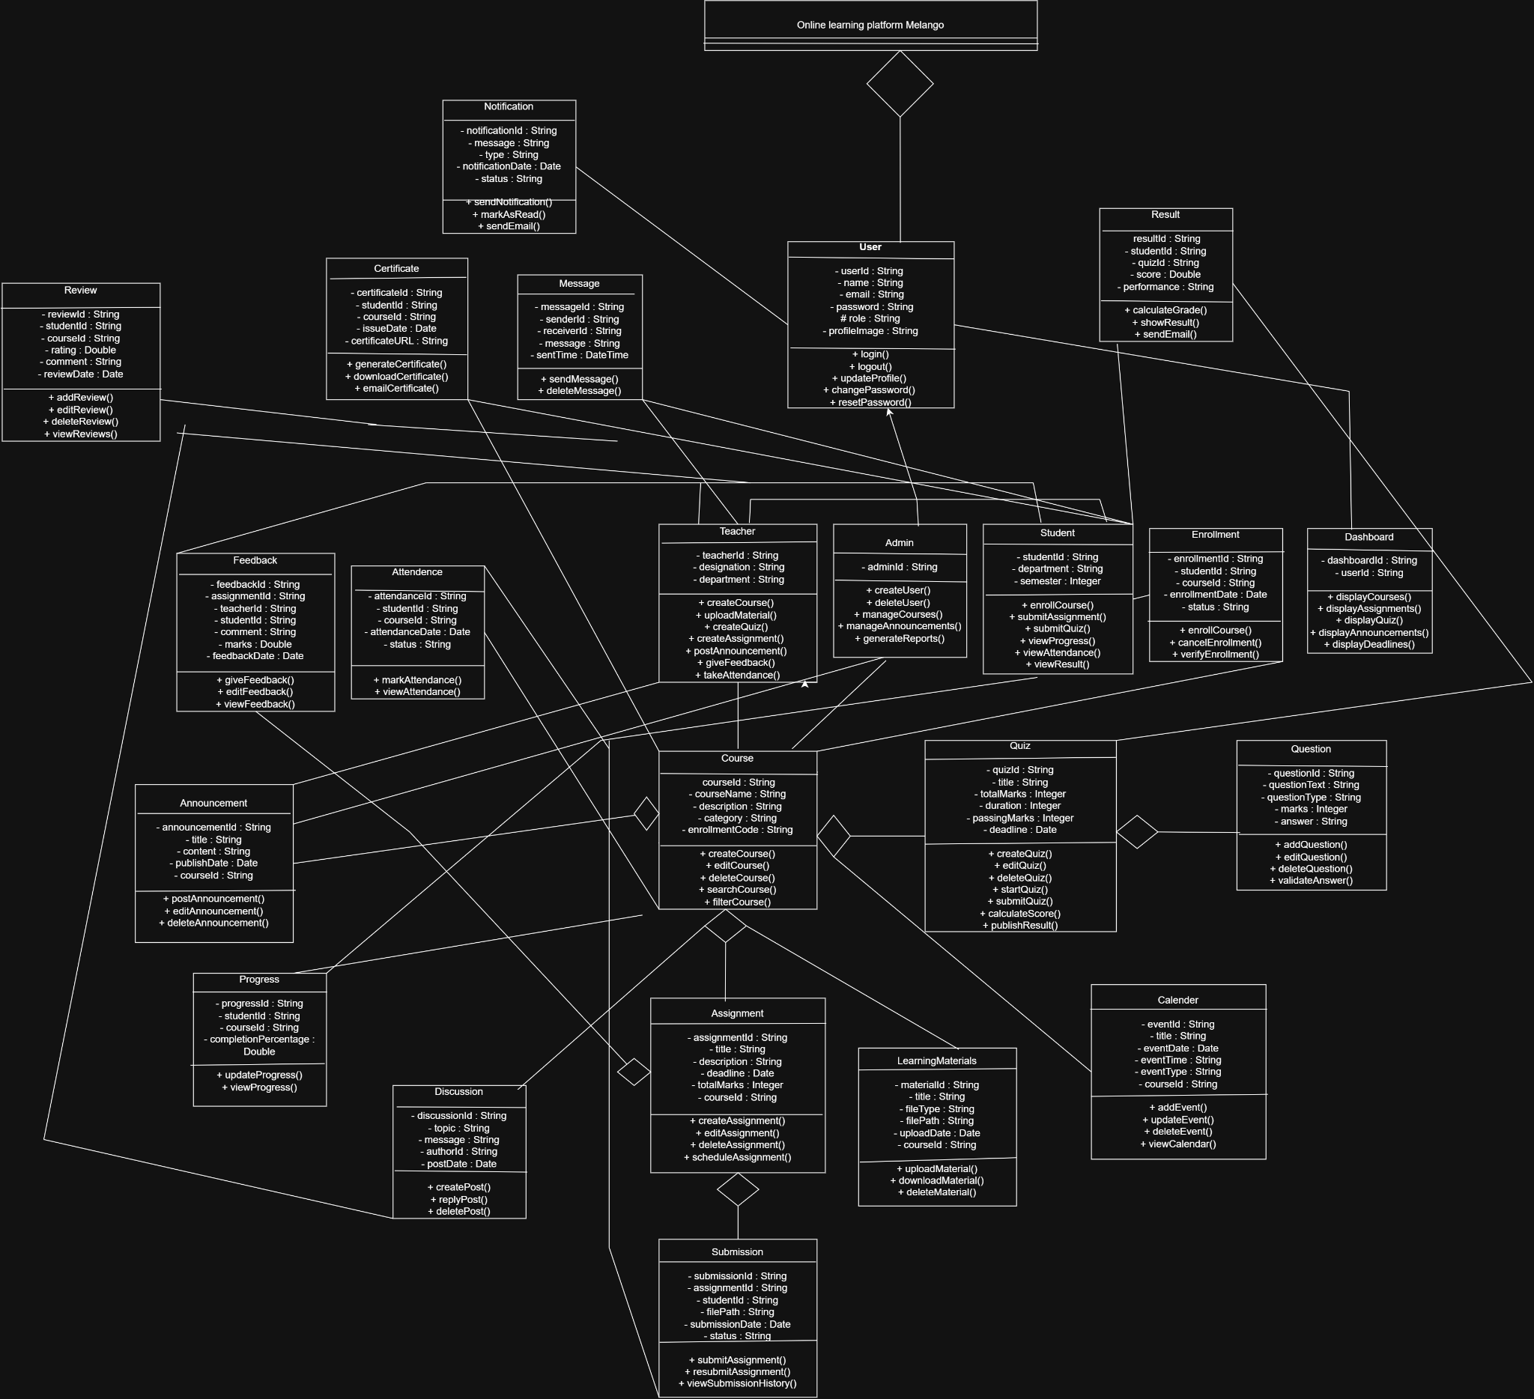

7. Conclusion
This SRS provides a detailed outline for the design and development of "Melango", a comprehensive online learning web application built using the MERN stack. The platform aims to provide an engaging, secure, and user-friendly learning environment by integrating essential educational features such as course management, assignment handling, learning material repositories, announcements, discussions, progress tracking, and certificate generation. By following the planned Agile development process and implementing the MVC architecture, the project aims to deliver a scalable, maintainable, and efficient learning platform within the designated project timeline.

